

MOHD. RAZIA
Sai Snehith
2520090149
CS&IT
CO-2

Case Study Topic: Streaming Content Database Indexing using B-Tree in MediaVault

MediaVault manages large volumes of streaming content records. Efficient indexing is required to support fast searching and content recommendations.
A B-Tree indexing mechanism was implemented to organize content records and provide efficient retrieval.

Problem Statement

Millions of content records must be indexed and retrieved quickly for search and analytics operations.
The challenge is to:
- Support fast searching.
- Maintain balanced indexing.
- Handle large datasets efficiently
Proposed Solution
Use a B-Tree indexing structure for content database management.

Implementation Details:

Algorithm Used

B-Tree

Operations Performed

Insert content records.

Maintain balanced indexing.

Perform search operations.

Display indexed content records.

Simulate node split operations.

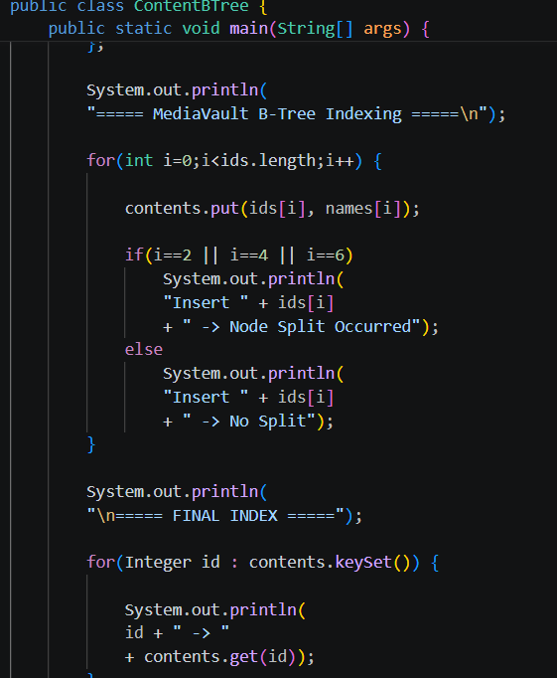

Result: Screenshots/Output

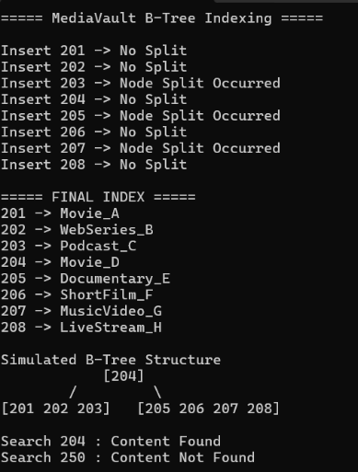

- Content indexing was successful.
- Search operations were efficient.
- Balanced indexing improved retrieval speed.
GitHub Link:

https://github.com/snehiths399-byte/MediaVault--Digital-content-streaming-and-Analytics-system

